23 June 2024
Linux Extra Workshop
#How to set Hostname in Linux#

# First determine name of Host to use in accordance to Name convention#

#Naming Convention is first 4 letters of first name + first initial of last name#

#babsk#

#Become root-user (sudo)#

#how to delete users in Linux#

#first verify the last two users stored in /etc/passwd#

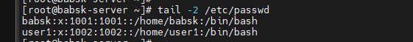

# First verify status of users to be deleted#

#Then delete the required users

#Then verify that user has been deleted#

#how to create users in Linux#

#first verify of users stored in /etc/passwd and status of users to be created#



# Become Root user (sudo)#

#Verify that the required users has been created#

useradd baba1 && echo baba11 | passwd --stdin baba1

exit

